

**About families…**

They say a picture is worth a thousand words. What words does this picture, taken by Cousin Tillie, have to tell? A hardworking family spanning many generations. Did Tillie chose the trees to represent the connections between them all I wonder?

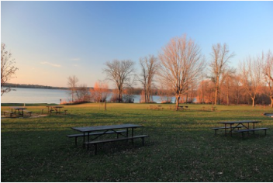

The site of the annual Kuchar family reunion by Tillie Gorski, taken in 2016